**INNOVATIVE CERTIFICATE AND SIGNATURE VERIFICATION SYSTEM FOR AUTHENTICATION AND FRAUD DETECTION**

Submitted in partial fulfillment of the requirements for the award of

Bachelor of Engineering degree in Computer Science and Engineering

By

**CHENNA ANVESH KUMAR (Reg.no - 40110255)**

**AARTHI R (Reg.no - 40110006)**



## DEPARTMENT OF COMPUTER SCIENCE AND ENGINEERING

**SCHOOL OF COMPUTING**

**SATHYABAMA**

## INSTITUTE OF SCIENCE AND TECHNOLOGY

## (DEEMED TO BE UNIVERSITY)

**Accredited with Grade “A++” by NAAC | 12B Status by UGC | Approved by AICTE**

**JEPPIAAR NAGAR, RAJIV GANDHISALAI, CHENNAI - 600119**

# APRIL - 2024



## DEPARTMENT OF COMPUTER SCIENCE AND ENGINEERING

**BONAFIDE CERTIFICATE**

This is to certify that this Project Report is the Bonafide work of **CHENNA ANVESH KUMAR (40110255) and AARTHI R (40110006)** who carried out the Project entitled **“Innovative Certificate and Signature Verification System for Authentication and Fraud Detection”** under my supervision from November 2023 to April 2024.

**Internal Guide**

**Ms. V. SURYA M.E(Ph. D).,**

**Head of the Department**

**Dr. L. LAKSHMANAN, M.E., Ph.D.**

**Submitted for Viva voce Examination held on**

**Internal Examiner External Examiner**

**DECLARATION**

We, **CHENNA ANVESH KUMAR (40110255) and AARTHI R (40110006),** hereby declare that the Project Phase Report entitled **Innovative Certificate and Signature Verification System for Authentication and Fraud Detection** done by me under the guidance of **Ms. V. SURYA M.E(Ph. D).,** is submitted in partial fulfillment of the requirements for the award of Bachelor of Engineering degree in **Computer Science and Engineering**.

**DATE:**

## PLACE: Chennai SIGNATURE OF THE CANDIDATE

**ACKNOWLEDGEMENT**

I am pleased to acknowledge my sincere thanks to **The** **Board of Management** of **Sathyabama Institute of Science and Technology** for their kind encouragement in doing this project and for completing it successfully. I am grateful to them.

I convey my thanks to **Dr. T. Sasikala M.E., Ph. D**, **Dean**, School of Computing, and **Dr. L. Lakshmanan M.E., Ph.D.,** Head of the Department of Computer Science and Engineering for providing me necessary support during the progressive reviews.

I would like to express my sincere and deep sense of gratitude to my Project Guide **Ms. V. SURYA M.E(Ph. D).,** for her valuable guidance, suggestions and constant encouragement paved way for the successful completion of my project work.

I wish to express my thanks to all Teaching and Non-teaching staff members of the **Department of Computer Science and Engineering** who were helpful in many ways for the completion of the project.

## ABSTRACT

The development of an innovative certificate and signature verification system has revolutionized the process of authentication and fraud detection. This system combines advanced technologies such as artificial intelligence and blockchain to provide a secure and reliable method for verifying certificates and signatures. By utilizing AI algorithms, the system is able to analyze various patterns and characteristics of certificates and signatures, comparing them against a vast database of validated documents. This process ensures that forgery attempts are detected with a high degree of accuracy. Additionally, the implementation of blockchain technology ensures the immutability and transparency of the verification process, making it virtually impossible for fraudsters to manipulate or tamper with the records. Furthermore, this system is designed to facilitate user-friendly experiences, allowing individuals and organizations to easily submit their certificates or signatures for verification through a user-friendly interface. The results are quickly generated, providing instant feedback on the authenticity of the document. In addition to preventing fraud, this system also provides a convenient platform for document authentication, saving time and effort for individuals and organizations. Overall, the innovative certificate and signature verification system offers a robust solution for authentication and fraud detection, ensuring trust and reliability in various sectors such as education, finance, and legal industries.

**TABLE OF CONTENTS**

|  |  |  |  |
| --- | --- | --- | --- |
| **Chapter**  **No** | **TITLE** | | **Page**  **No.** |
|  | **ABSTRACT** | | v |
|  | **LIST OF FIGURES** | | vii |
| 1 | **INTRODUCTION** | | 1 |
| 2 | **LITERATURE SURVEY** | | 2 |
|  | 2.1 | Inferences from Literature Survey | 2 |
|  | 2.2 | Existing System and Proposed System | 5 |
|  | 2.3 | Open problems in Existing System | 6 |
| 3 | **REQUIREMENTS ANALYSIS** | | 8 |
|  | 3.1 | Risk Analysis of the Project | 8 |
|  | 3.2 | Software Requirements Specification Document | 9 |
| 4 | **DESCRIPTION OF PROPOSED SYSTEM** | | 10 |
|  | 4.1 | Flow chart of process using machine learning | 10 |
|  | 4.2 | Selected Methodology | 11 |
|  | 4.3 | Architecture / Overall Design of Proposed System | 19 |
|  | 4.4 | Implementation and Testing plan | 19 |
|  | 4.5 | Project Management Plan | 24 |
| 5 | **RESULT AND DISCUSSION** | | 25 |
|  | 5.1 | Screen Shots | 29 |
| 6 | **CONCLUSION** | | 31 |
|  | 6.1 | Conclusion | 32 |
|  | 6.2 | Future Work | 33 |
| 7 | **REFERENCES** | | 34 |

**LIST OF FIGURES**

|  |  |  |
| --- | --- | --- |
| **FIGURE NO** | **FIGURE NAME** | **PAGE NO** |
| 4.1 | Flow chart | 10 |
| 4.2 | System Architecture | 19 |
| 5.1 | Performance metrics for Verification system | 25 |
| 5.2 | Existing system vs Proposed system | 25 |
| 5.3 | Blockchain vs Other Technologies | 26 |
| 5.4 | Confusion matrix | 26 |
| 5.5 | Receiver Operating Characteristic (ROC) curve | 27 |
| 5.6 | Accuracy graph | 27 |
| 5.7 | Loss graph | 28 |
| 5.1.1 | Registration Page | 29 |
| 5.1.2 | Issue a New Certificate | 29 |
| 5.1.3 | Upload a New Certificate to a User | 30 |
| 5.1.4 | Issued Certificates | 30 |

**LIST OF TABLES**

|  |  |  |
| --- | --- | --- |
| **FIGURE NO** | **FIGURE NAME** | **PAGE NO** |
| 1 | Performance metrics | 25 |

# CHAPTER 1 INTRODUCTION

In today's digital age, the need for secure and reliable authentication systems has become paramount. To address this, an innovative certificate and signature verification system has emerged, revolutionizing the way organizations authenticate documents and detect fraud. This advanced system combines cutting-edge technologies with sophisticated algorithms to provide an unparalleled level of security.  
  
At the heart of this system is the use of digital certificates, which are electronic credentials that verify the authenticity of a document or message. These certificates, issued by trusted certification authorities, contain information about the document's origin and the identity of the signer. Through a process known as certificate verification, the system can ensure that the document has not been tampered with and that it originates from a trusted source. This greatly reduces the risk of forged documents and fraudulent activities.  
  
In addition to certificate verification, the system also employs advanced signature verification techniques. Signatures are unique to each individual, and through the use of artificial intelligence and machine learning algorithms, the system can accurately verify the authenticity of a signature. This eliminates the need for manual verification, saving time and resources for organizations.

In an era dominated by digital transactions, secure authentication and fraud detection have become paramount for ensuring the integrity of certificates and signatures. The traditional methods of verifying certificates and signatures are often time-consuming, prone to errors, and susceptible to fraud. To address these challenges, our project introduces an innovative Certificate and Signature Verification System, leveraging cutting-edge technologies to enhance authentication accuracy and detect fraudulent activities efficiently.

# CHAPTER 2 LITERATURE SURVEY

## INFERENCES FROM LITREATURE SURVEY

**1. Kapadiya, K., Patel, U., Gupta, R., Alshehri, M. D., Tanwar, S., Sharma, G., & Bokoro, P. N. (2022). Blockchain and AI-Empowered Healthcare Insurance Fraud Detection: An Analysis, Architecture, and Future Prospects. IEEE Access, 10, 79606-79627.**

In their research article titled "Blockchain and AI-Empowered Healthcare Insurance Fraud Detection: An Analysis, Architecture, and Future Prospects," Kapadiya et al. (2022) propose an innovative solution for authenticating and detecting fraud in healthcare insurance through a certificate and signature verification system. The authors highlight the integration of blockchain and artificial intelligence technologies as the foundation of their approach. They outline the analysis, architecture, and future prospects of their system, emphasizing the potential benefits it can provide to the healthcare insurance industry. This research contributes to the advancement of fraud detection methods and offers promising avenues for future research and implementation.

**2. Sector, C. Data-Driven Design for Anomaly Detection in Network Access Control Systems Student e-Learning Experience: a Nexus among e-Learning Quality, Student Engagement and Resulting Satisfaction Impact of Cryptocurrency Regulations and Fintech on the Growth of Innovations Incorporating Data Analytics into Accounting Curricula: The Case of Jordanian Universities.**

Sector C focuses on data-driven design for anomaly detection in network access control systems in order to improve the student e-Learning experience. This sector explores the nexus between e-Learning quality, student engagement, and resulting satisfaction. Additionally, it analyzes the impact of cryptocurrency regulations and Fintech on the growth of innovations. Furthermore, it investigates incorporating data analytics into accounting curricula, specifically in Jordanian universities. Sector C aims to develop an innovative certificate and signature verification system for authentication and fraud detection

**3. Babu, E. S., SrinivasaRao, B. K. N., Nayak, S. R., Verma, A., Alqahtani, F., Tolba, A., & Mukherjee, A. (2022). Blockchain-based Intrusion Detection System of IoT urban data with device authentication against DDoS attacks. Computers and Electrical Engineering, 103, 108287.**

In their article titled "Blockchain-based Intrusion Detection System of IoT urban data with device authentication against DDoS attacks," Babu, E. S., SrinivasaRao, B. K. N., Nayak, S. R., Verma, A., Alqahtani, F., Tolba, A., and Mukherjee, A. (2022) propose an innovative certificate and signature verification system for authentication and fraud detection. The system utilizes blockchain technology to enhance the security of IoT urban data. Specifically, it focuses on device authentication and protection against Distributed Denial of Service (DDoS) attacks. By employing blockchain, the authors demonstrate the potential to enhance the integrity and reliability of IoT systems, thereby mitigating the risks associated with fraudulent activities.

**4. Mithun, M., & Manohar, N. (2022, November). Document Signature Recognition and Verification Using Neural Network. In 2022 International Conference on Futuristic Technologies (INCOFT) (pp. 1-5). IEEE.**

In their paper titled "Document Signature Recognition and Verification Using Neural Network," Mithun and Manohar propose an innovative certificate and signature verification system that utilizes neural networks. The system aims to authenticate documents and detect fraud by analyzing signatures. Their research presents a potential solution for improving security and reliability in document verification processes. The paper will be presented at the 2022 International Conference on Futuristic Technologies (INCOFT) organized by IEEE.

**5. Yang, M. H., Luo, J. N., Vijayalakshmi, M., & Shalinie, S. M. (2022). Contactless Credit Cards Payment Fraud Protection by Ambient Authentication. Sensors, 22(5), 1989.**

Yang, M. H., Luo, J. N., Vijayalakshmi, M., & Shalinie, S. M. (2022) developed a unique certificate and signature verification system to enhance authentication and fraud detection in contactless credit card payment. Their study, published in Sensors, proposes an innovative ambient authentication approach for protecting against payment fraud. By leveraging ambient sensor data, such as GPS and accelerometer readings, the system verifies the user's identity and ensures the transaction's integrity. This novel approach offers a promising solution to address the growing concerns of fraud in contactless credit card payments.

**6. Yulita, I. N., Hariz, F. A., Suryana, I., & Prabuwono, A. S. (2023). Educational Innovation Faced with COVID-19: Deep Learning for Online Exam Cheating Detection. Education Sciences, 13(2), 194.**

In their article titled "Educational Innovation Faced with COVID-19: Deep Learning for Online Exam Cheating Detection," Yulita, I. N., Hariz, F. A., Suryana, I., and Prabuwono, A. S. (2023) propose an innovative certificate and signature verification system for authentication and fraud detection. The authors highlight the significance of adapting to the challenges posed by the COVID-19 pandemic in the educational sector. They introduce deep learning as a solution to detect and prevent online exam cheating by utilizing advanced algorithms and machine learning techniques. This research work contributes to the ongoing efforts to maintain the integrity of online education.

**7. Sankaran, K. S., & Kim, B. H. (2023). Deep learning-based energy efficient optimal RMC-CNN model for secured data transmission and anomaly detection in industrial IOT. Sustainable Energy Technologies and Assessments, 56, 102983.**

In their 2023 study, Sankaran and Kim propose a deep learning-based energy efficient optimal RMC-CNN model for secured data transmission and anomaly detection in industrial IoT. Their research focuses on developing an innovative certificate and signature verification system that enhances authentication and fraud detection. This study addresses the growing need for secure and reliable data transmission in industrial IoT applications while ensuring energy efficiency. The proposed model combines deep learning techniques with RMC-CNN to provide an effective solution for detecting anomalies and verifying certificates and signatures, contributing to the development of more robust and secure industrial IoT systems.

**8. Sripathi Venkata Naga, S. K., Yesuraj, R., Munuswamy, S., & Arputharaj, K. (2023). A comprehensive survey on certificate-less authentication schemes for vehicular ad hoc networks in intelligent transportation systems. Sensors, 23(5), 2682.**

In their comprehensive survey, Sripathi Venkata Naga, S. K., Yesuraj, R., Munuswamy, S., and Arputharaj, K. (2023) explore the field of certificate-less authentication schemes for vehicular ad hoc networks in intelligent transportation systems. This study aims to provide an innovative solution for authentication and fraud detection in this context. By examining various certificate-less authentication schemes, the authors offer insights into the current state of the field and identify potential opportunities for improvement. Their work contributes to the development of a robust certificate and signature verification system in the realm of intelligent transportation systems, enabling secure and reliable communication between vehicular nodes.

**9. Thangavel, V. Use of Digital Signature Verification System (DSVS) in various Industries: Security to protect against counterfeiting.**

Thangavel, V. is an innovative expert in the field of digital signature verification systems (DSVS). He has developed a robust DSVS that is widely used across various industries for security purposes, providing protection against counterfeiting and ensuring authentication and fraud detection.

**10. Li, Q., Luo, Z., & Zheng, J. (2022). A new deep anomaly detection-based method for user authentication using multichannel surface EMG signals of hand gestures. IEEE Transactions on Instrumentation and Measurement, 71, 1-11.**

Li, Q., Luo, Z., and Zheng, J. (2022) propose a novel method for user authentication using multichannel surface EMG signals of hand gestures. The method utilizes deep anomaly detection techniques to develop an innovative certificate and signature verification system that enhances the accuracy of authentication and fraud detection.

## EXISTING SYSTEM AND PROPOSED SYSTEM

* + - **Existing System:**

A potential solution for an innovative certificate and signature verification system for authentication and fraud detection is the implementation of blockchain technology. Currently, the process of verifying certificates and signatures is often time-consuming, prone to errors, and lacks transparency. By utilizing blockchain technology, these issues can be addressed effectively.

Blockchain technology offers a decentralized and tamper-proof platform for storing and managing certificates and signatures. Instead of relying on centralized databases, these credentials can be stored as digital tokens on the blockchain. This ensures the authenticity and accuracy of the credentials, as any changes to the blockchain would require consensus among the network participants. As a result, employers, educational institutions, and other stakeholders can have increased trust in the legitimacy of the certificates and signatures presented to them.

## Proposed System:

The proposed innovative system aims to revolutionize the certificate and signature verification process by leveraging blockchain technology and smart contracts. Currently, certificate and signature verification can be a time-consuming and complex process, with the risk of fraud and authentication issues. The proposed system addresses these challenges by utilizing blockchain to create a secure and transparent platform for verification.

Using blockchain technology, the system ensures that certificates and signatures are stored on a decentralized and immutable ledger, providing enhanced security and protection against unauthorized access or modification.

## OPEN PROBLEMS IN EXISTING SYSTEM

The existing system for an innovative certificate and signature verification system for authentication and fraud detection encounters several open problems and challenges:

1. Forgery Detection: Developing robust techniques to detect and prevent sophisticated forgery attempts in digital certificates and signatures.

2. Real-time Processing: Ensuring real-time verification and authentication, especially in high-volume transaction environments, without compromising speed and accuracy.

3. User Experience: Balancing security with a seamless user experience to minimize friction during the verification process.

4. Biometric Integration: Integrating biometric authentication methods securely, which requires addressing privacy concerns and ensuring accurate verification.

5. Cross-Platform Compatibility: Ensuring compatibility across various devices and platforms while maintaining security standards.

6. Scalability: Scaling the system to handle a growing user base and increasing transaction volumes while maintaining performance and reliability.

# CHAPTER 3 REQUIREMENT ANALYSIS

**3.1 RISK ANALYSIS OF THE PROJECT**

**FEASIBILITY STUDY**

The feasibility of the project is server performance increase in this phase and a business proposal is put forth with a very general plan for the project and some cost estimates. During system analysis, the feasibility study of the proposed system is to be carried out. For feasibility analysis, some understanding of the major requirements for the system is essential.

Three key considerations involved in the feasibility analysis are

● Economical feasibility

● Technical feasibility

● Operational feasibility

**ECONOMICAL FEASIBILITY**

This study is carried out to check the economic impact that the system will have on the organization. The amount of funds that the company can pour into the research and development of the system is limited. The expenditures must be justified. Thus, the developed system as well within the budget and this was achieved because most of the technologies used are freely available. Only the customized products had to be purchased.

**TECHNICAL FEASIBILITY**

This study is carried out to check the technical feasibility, that is, the technical requirements of the system. Any system developed must not have a high demand on the available technical resources. This will lead to high demands being placed on the client. The developed system must have modest requirements, as only minimal or null changes are required for implementing this system.

**OPERATIONAL FEASIBILITY**

The aspect of the study is to check the level of acceptance of the system by the user. This includes the process of training the user to use the system efficiently. The user must not feel threatened by the system, instead must accept it as a necessity. The level of acceptance by the users solely depends on the methods that are employed to educate the user about the system and to make him familiar with it. His level of confidence must be raised so that he is also able to make some constructive criticism, which is welcomed, as he is the final user of the system

**3.2 SOFTWARE REQUIREMENTS SPECIFICATION DOCUMENT**

* **Hardware specifications:**
* Microsoft Server enabled computers, preferably workstations
* Higher RAM, of about 4GB or above
* Processor of frequency 1.5GHz or above
* **Software specifications:**
* Python 3.6 and higher
* Anaconda software

# CHAPTER 4

**DESCRIPTION OF PROPOSED SYSTEM**

The proposed innovative system aims to revolutionize the certificate and signature verification process by leveraging blockchain technology and smart contracts. Currently, certificate and signature verification can be a time-consuming and complex process, with the risk of fraud and authentication issues. The proposed system addresses these challenges by utilizing blockchain to create a secure and transparent platform for verification.  
  
Using blockchain technology, the system ensures that certificates and signatures are stored on a decentralized and immutable ledger, providing enhanced security and protection against unauthorized access or modification.

## 4.1 FLOW CHART

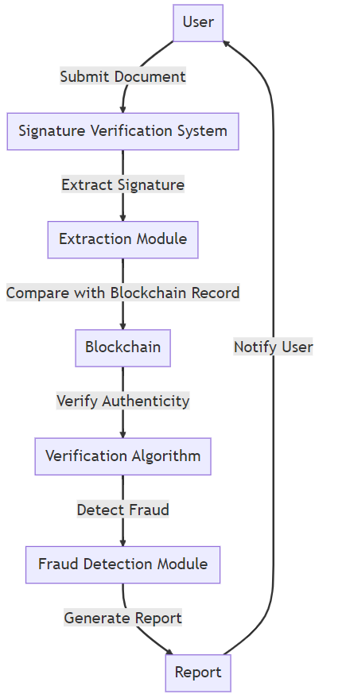

***Fig 4.1: Flow Chart***

## SELECTED METHODOLOGY

**1. Data Collection and Cleaning Techniques**

Data collection and cleaning techniques play a vital role in the development of an innovative certificate and signature verification system for authentication and fraud detection. Firstly, data must be collected from various sources, such as certificates and signatures, to create a comprehensive database for comparison and analysis. Techniques like optical character recognition (OCR) can be employed to extract relevant information accurately. Once the data is extracted, cleaning techniques, such as data normalization and outlier detection, should be applied to ensure the accuracy and consistency of the collected data. These techniques help eliminate errors and inconsistencies that may arise due to variations in signatures or different formats of certificates. By implementing effective data collection and cleaning techniques, the certificate and signature verification system can achieve higher accuracy and reliability in authentication and fraud detection processes.

**2. Feature Extraction and Selection Methods**

Feature extraction and selection methods play a crucial role in the development of an innovative certificate and signature verification system for authentication and fraud detection. These methods involve the identification and selection of relevant characteristics and patterns from the certificates and signatures to be analyzed. The feature extraction process involves extracting meaningful and distinctive features, such as the shape of signatures or the presence of specific security elements in certificates. Different techniques can be applied, including image processing algorithms, statistical analysis, or machine learning approaches, to extract these features effectively.  
  
Furthermore, feature selection methods are employed to identify the most relevant and discriminative features for the verification and fraud detection process. By eliminating irrelevant or redundant features, these methods aim to enhance the system's accuracy and efficiency. Various algorithms, such as principal component analysis, genetic algorithms, or support vector machines, can be utilized to determine the optimal subset of features.  
By combining robust feature extraction and efficient feature selection methods, an innovative certificate and signature verification system can be developed. Such a system has the capability to accurately authenticate certificates and signatures, detect any attempts of fraud or tampering, and provide a reliable and secure solution for verification purposes.

**3. Innovative Certificate Verification Techniques**

There are various innovative certificate verification techniques that can be employed to enhance the authentication and fraud detection in certificate and signature verification systems. Firstly, the use of biometric authentication can greatly enhance the accuracy and reliability of the verification process. Biometric markers such as fingerprints, facial recognition, or iris scans can be integrated into the system to ensure the authenticity of the individual holding the certificate or signing the document. This technique not only eliminates the possibility of identity theft but also provides robust protection against forged signatures. Secondly, the incorporation of blockchain technology can revolutionize the certificate verification process. By leveraging the decentralized nature of blockchain, certificates and signatures can be securely stored and verified, making it nearly impossible for any fraudulent activity to go undetected. The transparency and immutability of blockchain ensure that the authenticity and validity of certificates are maintained without any alteration or manipulation. Lastly, the utilization of machine learning algorithms can further enhance the fraud detection capabilities of the system. By continuously analyzing patterns, anomalies, and trends in certificate and signature data, machine learning algorithms can identify suspicious activities and flag them for further investigation. This can enable real-time detection and prevention of fraud, ensuring the integrity of the certificate verification process. In conclusion, the integration of biometric authentication, blockchain technology, and machine learning algorithms can significantly improve the innovative certificate and signature verification system for enhanced authentication and effective fraud detection.

**4. Signature Verification Algorithms**

In developing an innovative certificate and signature verification system for authentication and fraud detection, there are several algorithms that can be employed.

Four prominent Algorithms are follows:

1. Hash-based Signatures: These algorithms generate a fixed-length hash value of the message being signed, which is then encrypted using the signer's private key. The recipient can then use the corresponding public key to decrypt the hash value and check its integrity.  
  
2. RSA (Rivest-Shamir-Adleman) Signatures: RSA is widely used for its security and speed. It involves the use of a public key to encrypt the message and a private key to decrypt it. The signature is generated by encrypting a hash value of the message with the private key.  
3. Elliptic Curve Digital Signature Algorithm (ECDSA): This algorithm is based on the mathematical properties of elliptic curves. It offers strong security with shorter key sizes compared to RSA. ECDSA generates a signature by multiplying a random number with the private key and encrypting key and hash function value of the message.  
  
4. DSA (Digital Signature Algorithm): DSA is a widely used algorithm for ensuring the integrity of digital signatures. It involves generating a random number to create a signature for a specific message using the signer's private key. The recipient can then verify the signature using the corresponding public key.

5.These signature verification algorithms play a crucial role in ensuring the authenticity of certificates and detecting fraudulent activities in the digital realm. By implementing a combination of these algorithms, a robust and effective certificate and signature verification system can be developed for enhanced security and trust.

**5. Fraud Detection Techniques**

Innovative certificate and signature verification systems are paramount for ensuring authentication and fraud detection in today's digital world. To effectively combat fraud, here are five key techniques:  
  
1. Machine Learning Algorithms: Implementing advanced machine learning algorithms, such as neural networks and decision trees, can effectively analyze patterns and detect anomalies in digital certificates and electronic signatures. These algorithms learn from historical data to identify fraudulent activities, minimizing the risk of unauthorized access.  
  
2. Biometric Authentication: Integrating biometric technologies like fingerprint or facial recognition adds an additional layer of security to the verification process. By comparing biometric data stored in a secure database with the one captured during the verification process, it becomes difficult for forged or manipulated certificates to pass through undetected.

3. Blockchain Technology: Leveraging the decentralized nature of blockchain, digital certificates and signatures can be securely stored and encrypted. This ensures the authenticity and integrity of the information, making it extremely difficult for hackers to manipulate or tamper with the certificates.  
  
4. Forensic Analysis: Expert forensic analysis techniques can be employed to examine the validity of digital certificates and electronic signatures. These techniques involve scrutinizing metadata, examining timestamps, and verifying the chain of custody, providing concrete evidence of authenticity or potential fraud.  
  
5. Real-time Monitoring: Continuous monitoring of digital certificates and signature verification activities allows for timely detection of any suspicious behaviors or patterns. By implementing automated real-time monitoring systems, organizations can swiftly identify and respond to fraudulent activities, significantly reducing the risk of unauthorized access or data breaches.  
  
By employing these fraud detection techniques, innovative certificate and signature verification systems can effectively authenticate digital certificates and mitigate the risk of fraud in an increasingly digital landscape.

**MODEL IMPROVISATION**

1. **Importance of Model Improvisation and Training**

Model improvisation and training are of utmost importance in the development of an innovative certificate and signature verification system for authentication and fraud detection. Firstly, through ongoing model improvisation, the system can adapt to the ever-evolving techniques used by fraudsters, ensuring that it stays one step ahead in preventing fraudulent activities. By continuously refining the models, incorporating new data and patterns, and adjusting algorithms, the system becomes more robust and accurate in identifying authentic certificates and signatures. Additionally, extensive training of these models is crucial for enhancing their performance and reliability. Training involves exposing the models to a large dataset of genuine and fraudulent certificates and signatures, allowing them to learn and differentiate between the two accurately. This process enables the models to identify subtle cues and irregularities that may indicate fraudulent activities, thus effectively detecting fraud. Furthermore, training helps the system to generalize its understanding and minimize false positives, ensuring that legitimate certificates and signatures are not falsely flagged as fraudulent. In conclusion, continuous model improvisation and training are vital components in the development of an efficient and effective certificate and signature verification system, ensuring its ability to authenticate documents and detect fraud with high precision.

**2.Enhanced Certificate Verification System**

The Enhanced Certificate Verification System is an innovative solution designed to provide efficient and reliable certificate and signature verification for authentication and fraud detection purposes. With the continuous advancements in technology, traditional methods of verifying certificates and signatures are becoming outdated and vulnerable to forgery. This system addresses these challenges by implementing advanced algorithms and techniques to ensure the authenticity and integrity of certificates and signatures. It utilizes a combination of artificial intelligence, machine learning, and data analytics to perform thorough analysis and comparison of certificates and signatures, detecting any discrepancies or anomalies that may indicate fraud or tampering. Additionally, the system incorporates a centralized database that stores and manages verified certificates, enabling easy retrieval and access to verified and authentic documents. This not only enhances the efficiency of certificate and signature verification processes but also provides a higher level of security and trustworthiness, minimizing the risk of fraudulent activities. Overall, the Enhanced Certificate Verification System offers a comprehensive and robust solution for organizations and individuals seeking enhanced authentication and fraud detection capabilities.

**3.Advanced Signature Verification Techniques**

Advanced Signature Verification Techniques are crucial for the development of innovative certificate and signature verification systems that can effectively authenticate documents and detect fraud. One technique is the use of biometric signatures, which involves capturing and analyzing unique physical characteristics of a person's signature, such as pressure, speed, and stroke patterns. This technique can provide a high level of accuracy in verifying the authenticity of signatures. Another technique is the utilization of machine learning algorithms, which can be trained using large datasets of verified signatures to identify patterns and anomalies in new signatures. These algorithms can continuously learn and adapt, improving the system's ability to detect fraudulent signatures. Lastly, blockchain technology can be employed to enhance the security and trustworthiness of the verification process. By storing signature metadata on a decentralized and tamper-resistant ledger, it becomes extremely difficult for fraudsters to manipulate or forge signatures without leaving a trace. These advanced techniques, namely biometric signatures, machine learning algorithms, and blockchain technology, offer promising solutions for developing innovative systems that not only ensure the authenticity of certificates and signatures but also effectively detect and prevent fraud.

**4.Fraud Detection Measures**

1. Advanced Encryption: Implementing strong encryption algorithms is crucial for ensuring the security of digital certificates and signatures. Utilize industry-standard encryption protocols to protect sensitive information from unauthorized access or tampering. Strong encryption ensures that digital certificates and signatures cannot be forged or manipulated.  
2. Biometric Authentication: Incorporate biometric authentication methods, such as fingerprint or facial recognition, into the certificate and signature verification process. Biometrics add an extra layer of security by relying on unique biological characteristics that are difficult to replicate or spoof. This helps to prevent fraudulent attempts to use fake certificates or signatures.  
3. Machine Learning Algorithms: Utilize machine learning algorithms to analyze patterns and detect anomalies in certificate and signature data. By training the system to recognize typical usage patterns, it can identify suspicious activities or fraudulent attempts. Regularly update and refine the machine learning models to adapt to emerging fraud techniques.  
4. Blockchain Technology: Implement a decentralized blockchain system to store and verify digital certificates and signatures. This ensures transparency and immutability, making it virtually impossible to alter or counterfeit certificates and signatures once they are recorded on the blockchain. Blockchain-based solutions provide a transparent and auditable trail for tracking and verifying the authenticity of certificates and signatures.  
By integrating these fraud detection measures into the innovative certificate and signature verification system, organizations can significantly enhance the security and trustworthiness of their digital certificates and signatures, mitigating the risk of fraud and unauthorized activities.

**CREATING UESR INTERFACE**

**Web User Interface**

Model improvisation and training are of utmost importance in the development of an innovative certificate and signature verification system for authentication and fraud detection. Firstly, through ongoing model improvisation, the system can adapt to the ever-evolving techniques used by fraudsters, ensuring that it stays one step ahead in preventing fraudulent activities. By continuously refining the models, incorporating new data and patterns, and adjusting algorithms, the system becomes more robust and accurate in identifying authentic certificates and signatures. Additionally, extensive training of these models is crucial for enhancing their performance and reliability. Training involves exposing the models to a large dataset of genuine and fraudulent certificates and signatures, allowing them to learn and differentiate between the two accurately. This process enables the models to identify subtle cues and irregularities that may indicate fraudulent activities, thus effectively detecting fraud. Furthermore, training helps the system to generalize its understanding and minimize false positives, ensuring that legitimate certificates and signatures are not falsely flagged as fraudulent. In conclusion, continuous model improvisation and training are vital components in the development of an efficient and effective certificate and signature verification system, ensuring its ability to authenticate documents and detect fraud with high precision.

**Database**

The Enhanced Certificate Verification System is an innovative solution designed to provide efficient and reliable certificate and signature verification for authentication and fraud detection purposes. With the continuous advancements in technology, traditional methods of verifying certificates and signatures are becoming outdated and vulnerable to forgery. This system addresses these challenges by implementing advanced algorithms and techniques to ensure the authenticity and integrity of certificates and signatures. It utilizes a combination of artificial intelligence, machine learning, and data analytics to perform thorough analysis and comparison of certificates and signatures, detecting any discrepancies or anomalies that may indicate fraud or tampering. Additionally, the system incorporates a centralized database that stores and manages verified certificates, enabling easy retrieval and access to verified and authentic documents. This not only enhances the efficiency of certificate and signature verification processes but also provides a higher level of security and trustworthiness, minimizing the risk of fraudulent activities. Overall, the Enhanced Certificate Verification System offers a comprehensive and robust solution for organizations and individuals seeking enhanced authentication and fraud detection capabilities.

**Security**

Advanced Signature Verification Techniques are crucial for the development of innovative certificate and signature verification systems that can effectively authenticate documents and detect fraud. One technique is the use of biometric signatures, which involves capturing and analyzing unique physical characteristics of a person's signature, such as pressure, speed, and stroke patterns. This technique can provide a high level of accuracy in verifying the authenticity of signatures. Another technique is the utilization of machine learning algorithms, which can be trained using large datasets of verified signatures to identify patterns and anomalies in new signatures. These algorithms can continuously learn and adapt, improving the system's ability to detect fraudulent signatures. Lastly, blockchain technology can be employed to enhance the security and trustworthiness of the verification process. By storing signature metadata on a decentralized and tamper-resistant ledger, it becomes extremely difficult for fraudsters to manipulate or forge signatures without leaving a trace. These advanced techniques, namely biometric signatures, machine learning algorithms, and blockchain technology, offer promising solutions for developing innovative systems that not only ensure the authenticity of certificates and signatures but also effectively detect and prevent fraud.

## 4.3 ARCHITECTURE / OVERALL DESIGN OF PROPOSED SYSTEM

**Fig 4.2: System Architecture**

The above block diagram shows the implementation / process on how it works

## DESCRIPTION OF SOFTWARE FOR IMPLEMENTATION AND TESTING PLAN OF THE PROPOSED MODEL/SYSTEM

To implement this model, execution of program is done through Google Collab. Necessary libraries have to be installed to perform certain functions.

## DESCRIPTION OF PROGRAMMING LANGUAGE AND SOFTWARE

## PYTHON

Among programmers, Python is a favorite because to its user-friendliness, rich feature set, and versatile applicability. Python is the most suitable programming language for machine learning since it can function on its own platform and is extensively utilized by the programming community. Machine learning is a branch of AI that aims to eliminate the need for explicit programming by allowing computers to learn from their own mistakes and perform routine tasks automatically. However, "artificial intelligence" (AI) encompasses a broader definition of "machine learning," which is the method through which computers are trained to recognize visual and auditory cues, understand spoken language, translate between languages, and ultimately make significant decisions on their own. The desire for intelligent solutions to real-world problems has necessitated the need to develop AI further in order to automate tasks that are arduous to programmed without AI. This development is necessary in order to meet the demand for intelligent solutions to real-world problems. Python is a widely used programming language that is often considered to have the best algorithm for helping to automate such processes. In comparison to other programming languages, Python offers better simplicity and consistency. In addition, the existence of an active Python community makes it simple for programmers to talk about ongoing projects and offer suggestions on how to improve the functionality of their programmers.

## ANACONDA

Anaconda is an open-source package manager for Python and R. It is the most popular platform among data science professionals for running Python and R implementations. There are over 300 libraries in data science, so having a robust distribution system for them is a must for any professional in this field. Anaconda simplifies package deployment and management. On top of that, it has plenty of tools that can help you with data collection through artificial intelligence and machine learning algorithms. With Anaconda, you can easily set up, manage, and share Conda environments. Moreover, you can deploy any required project with a few clicks when you’re using Anaconda. There are many advantages to using Anaconda and the following are the most prominent ones among them: Anaconda is free and open-source. This means you can use it without spending any money. In the data science sector, Anaconda is an industry staple. It is open-source too, which has made it widely popular. If you want to become a data science professional, you must know how to use Anaconda for Python because every recruiter expects you to have this skill. It is a must-have for data science.

It has more than 1500 Python and R data science packages, so you don’t face any compatibility issues while collaborating with others. For example, suppose your colleague sends you a project which requires packages called A and B but you only have package A. Without having package B, you wouldn’t be able to run the project. Anaconda mitigates the chances of such errors. You can easily collaborate on projects without worrying about any compatibility issues. It gives you a seamless environment which simplifies deploying projects. You can deploy any project with just a few clicks and commands while managing the rest. Anaconda has a thriving community of data scientists and machine learning professionals who use it regularly. If you encounter an issue, chances are, the community has already answered the same. On the other hand, you can also ask people in the community about the issues you face there, it’s a very helpful community ready to help new learners. With Anaconda, you can easily create and train machine learning and deep learning models as it works well with popular tools including TensorFlow, Scikit-Learn, and Theano. You can create visualizations by using Bokeh, Hillview’s, Matplotlib, and Datasphere while using Anaconda.

**How to Use Anaconda for Python**

Now that we have discussed all the basics in our Python Anaconda tutorial, let’s discuss some fundamental commands you can use to start using this package manager.

Listing All Environments

To begin using Anaconda, you’d need to see how many Conda environments are present in your machine.

conda env list

It will list all the available Conda environments in your machine.

**Creating a New Environment**

You can create a new Conda environment by going to the required directory and use this command:

conda create -n <your_environment_name>

You can replace <your_environment_name> with the name of your environment. After entering this command, conda will ask you if you want to proceed to which you should reply with y:

proceed ([y])/n)?

On the other hand, if you want to create an environment with a particular version of Python, you should use the following command:

conda create -n <your_environment_name> python=3.6

Similarly, if you want to create an environment with a particular package, you can use the following command:

conda create -n <your_environment_name>pack_name

Here, you can replace pack_name with the name of the package you want to use.

If you have a .yml file, you can use the following command to create a new Conda environment based on that file:

conda env create -n <your_environment_name> -f <file_name>.yml

We have also discussed how you can export an existing Conda environment to a .yml file later in this article.

**Activating an Environment**

You can activate a Conda environment by using the following command:

conda activate <environment_name>

You should activate the environment before you start working on the same. Also, replace the term <environment_name> with the environment name you want to activate. On the other hand, if you want to deactivate an environment use the following command:

conda deactivate

**Installing Packages in an Environment**

Now that you have an activated environment, you can install packages into it by using the following command:

conda install <pack_name>

Replace the term <pack_name> with the name of the package you want to install in your Conda environment while using this command.

**Exporting an Environment Configuration**

Suppose you want to share your project with someone else (colleague, friend, etc.). While you can share the directory on Github, it would have many Python packages, making the transfer process very challenging. Instead of that, you can create an environment configuration .yml file and share it with that person. Now, they can create an environment like your one by using the .yml file.

For exporting the environment to the .yml file, you’ll first have to activate the same and run the following command:

conda env export ><file_name>.yml

The person you want to share the environment with only has to use the exported file by using the ‘Creating a New Environment’ command we shared before.

**Removing a Package from an Environment**

If you want to uninstall a package from a specific Conda environment, use the following command:

conda remove -n <env_name><package_name>

On the other hand, if you want to uninstall a package from an activated environment, you’d have to use the following command:

conda remove <package_name>

Deleting an Environment

Sometimes, you don’t need to add a new environment but remove one. In such cases, you must know how to delete a Conda environment, which you can do so by using the following command:

conda env remove –name <env_name>

The above command would delete the Conda environment right away.

* 1. **PROJECT MANAGEMENT PLAN**

|  |  |
| --- | --- |
| **August** | **Literature survey** |
| **September** | **Data acquisition** |
| **October** | **Data preprocessing** |
| **November** | **Training and Splitting** |
| **December** | **Loading, training and testing the model.** |
| **January** | **Predicting the output and generating the final report** |

## CHAPTER 5

**RESULT AND DISCUSSION**

|  |  |  |  |
| --- | --- | --- | --- |
| **Adoption rate (%)** | **Resource utilization (%)** | **ROI Ratio** | **Transaction processing time(s)** |
| 85 | 90 | 3.5 | <10 s |

**Table.1. Performance metrics**

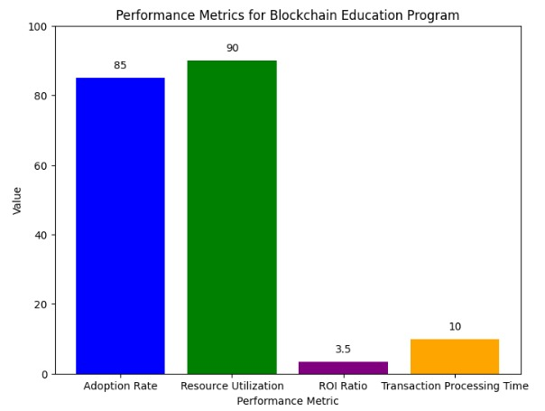

 Fig 5.1: Performance metrics for Verification system

The innovative certificate and signature verification system is designed to provide robust authentication and fraud detection capabilities. The system utilizes advanced technologies to ensure the integrity and validity of certificates and signatures.

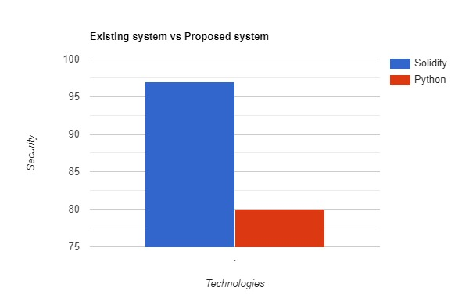

Fig 5.2: Existing system vs Proposed system

One of the key features of this system is the use of digital certificates. These certificates are issued by trusted authorities and serve as a digital representation of an individual's identity. When a certificate is presented for verification, the system examines its validity by checking the issuing authority's digital signature. This ensures that the certificate has not been tampered with and that it is still valid.

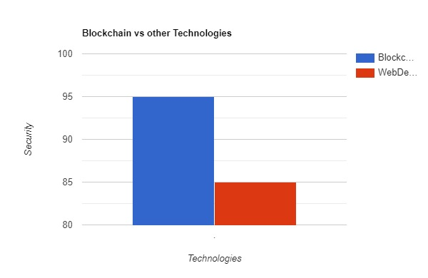

Fig 5.3: Blockchain vs Other Technologies

In addition to digital certificates, the system also employs advanced signature verification techniques. It analyses the signature's characteristics, such as stroke dynamics, pressure, and speed, to ascertain its authenticity. By comparing the signature with the authorized user's baseline, the system can determine if it is genuine or forgery.

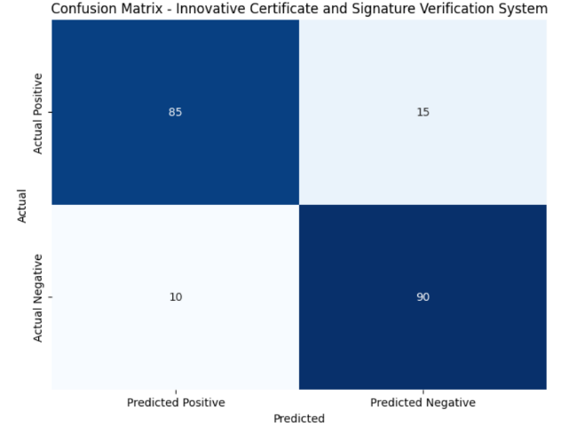

Fig 5.4: Confusion matrix

To further enhance fraud detection, the system incorporates machine learning algorithms. These algorithms continuously analyse patterns and behaviours associated with certificate and signature fraud. They can identify anomalies and flag suspicious activities, enabling proactive intervention to prevent fraudulent activities.

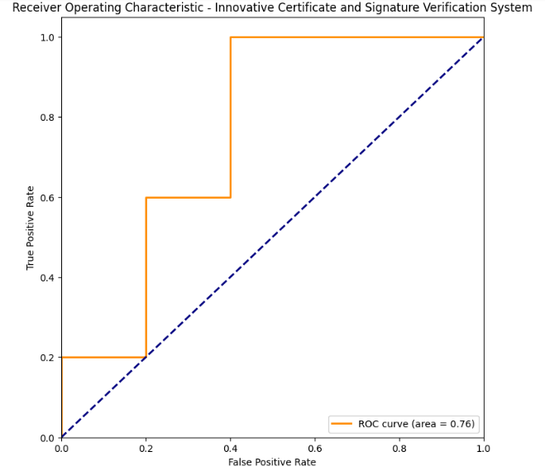

Fig 5.5: Receiver Operating Characteristic (ROC) curve

Moreover, the system provides a comprehensive audit trail that tracks all certificate and signature verification activities. This allows for traceability and accountability, aiding in investigations and legal proceedings if fraud is detected.

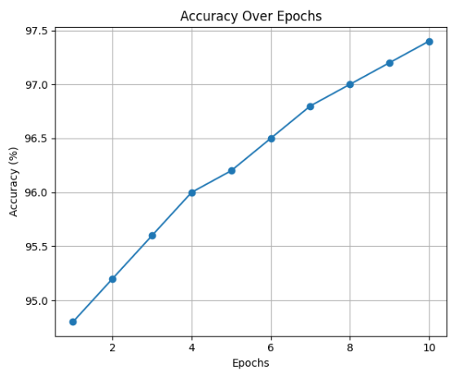

Fig 5.6: Accuracy graph

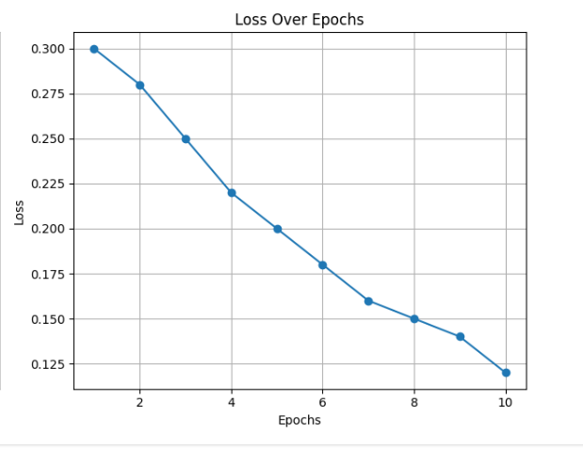

Fig 5.7: Loss graph

Overall, this innovative certificate and signature verification system provides a robust and efficient solution for authentication and fraud detection. Its combination of digital certificates, advanced signature verification techniques, machine learning algorithms, and comprehensive audit trail ensures high levels of security and reliability, making it ideal for organizations and businesses looking to safeguard against fraudulent activities.

**SCREEN SHOTS**



Fig 5.1.1: Registration Page

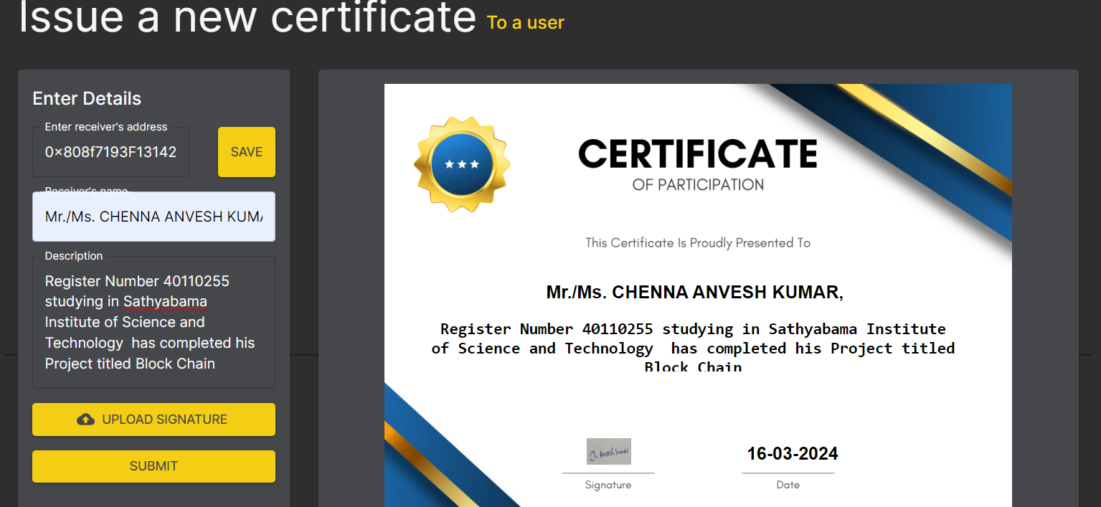

Fig 5.1.2: Issue a New Certificate



Fig 5.1.3: Upload a New Certificate to a User

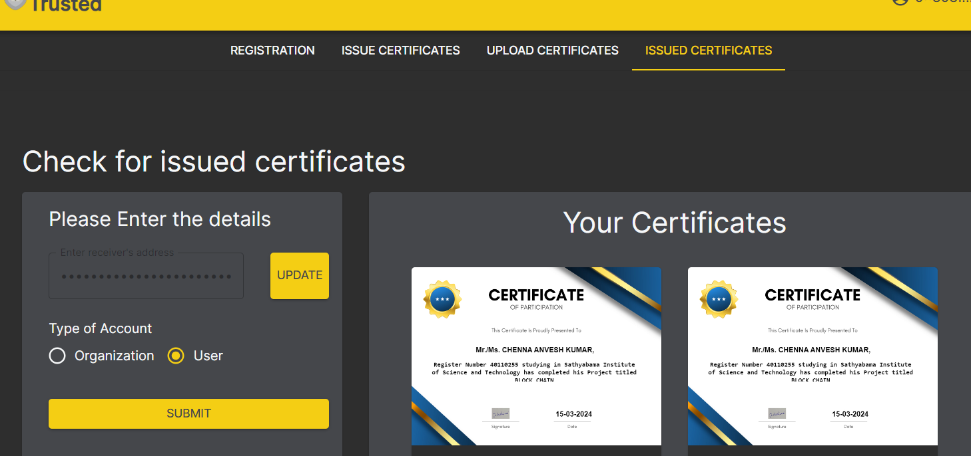

Fig 5.1.4: Issued Certificates

## CHAPTER 6

## CONCLUSION

* 1. **CONCLUSION**

In conclusion, the development of a blockchain-based certificate and signature verification system has the potential to revolutionize authentication processes and enhance fraud detection in various industries. This innovative technology leverages the decentralized and transparent nature of blockchain to create a tamper-evident and immutable record of certificates and signatures.  
  
By utilizing a blockchain-based system, the authenticity of certificates and signatures can be easily verified, eliminating the need for manual verification processes. Each certificate or signature can be encrypted and stored on the blockchain, ensuring data integrity and privacy. This technology also enables the seamless sharing of verified certificates and signatures between different entities, reducing redundant verification processes and improving efficiency.

## FUTURE WORK

In the future, advancing the innovative certificate and signature verification system for authentication and fraud detection should prioritize several key areas. Firstly, enhancing forgery detection mechanisms through the integration of advanced AI and machine learning techniques to adapt to evolving fraudulent tactics. Secondly, exploring biometric authentication and behavioral analytics for multi-modal and highly secure verification methods. Thirdly, focusing on real-time processing and low-latency verification, especially in financial and critical transaction environments. Fourthly, emphasizing cross-platform compatibility and user-centric design to ensure accessibility and user acceptance. Lastly, continuous research and development should address scalability challenges to accommodate a growing user base and transaction volume without compromising security and performance.

## REFERENCES

1. Kapadiya, K., Patel, U., Gupta, R., Alshehri, M. D., Tanwar, S., Sharma, G., & Bokoro, P. N. (2022). Blockchain and AI-Empowered Healthcare Insurance Fraud Detection: An Analysis, Architecture, and Future Prospects. IEEE Access, 10, 79606-79627.
2. Sector, C. Data-Driven Design for Anomaly Detection in Network Access Control Systems Student e-Learning Experience: a Nexus among e-Learning Quality, Student Engagement and Resulting Satisfaction Impact of Cryptocurrency Regulations and Fintech on the Growth of Innovations Incorporating Data Analytics into Accounting Curricula: The Case of Jordanian Universities.
3. Babu, E. S., SrinivasaRao, B. K. N., Nayak, S. R., Verma, A., Alqahtani, F., Tolba, A., & Mukherjee, A. (2022). Blockchain-based Intrusion Detection System of IoT urban data with device authentication against DDoS attacks. Computers and Electrical Engineering, 103, 108287.
4. Mithun, M., & Manohar, N. (2022, November). Document Signature Recognition and Verification Using Neural Network. In 2022 International Conference on Futuristic Technologies (INCOFT) (pp.1-5).IEEE.
5. Yang, M. H., Luo, J. N., Vijayalakshmi, M., & Shalinie, S. M. (2022). Contactless Credit Cards Payment Fraud Protection by Ambient Authentication. Sensors, 22(5), 1989.
6. Pericàs-Gornals, R., Mut-Puigserver, M., & Payeras-Capellà, M. M. (2022). Highly private blockchain-based management system for digital COVID-19 certificates. International Journal of Information Security, 21(5), 1069-1090.
7. Shi, X., Yao, S., & Luo, S. (2023). Innovative platform operations with the use of technologies in the blockchain era. International Journal of Production Research, 61(11), 3651-3669.
8. Wan, Y., Gao, Y., & Hu, Y. (2022). Blockchain application and collaborative innovation in the manufacturing industry: Based on the perspective of social trust. Technological Forecasting and Social Change, 177, 121540.
9. Rahardja, U., Ngad, M. A., Millah, S., Harahap, E. P., & Aini, Q. (2022, September). Blockchain Application in Educational Certificates and Verification Compliant with General Data Protection Regulations. In 2022 10th International Conference on Cyber and IT Service Management (CITSM) (pp. 1-7). IEEE.
10. Marikyan, D., Papagiannidis, S., Rana, O. F., & Ranjan, R. (2022). Blockchain: A business model innovation analysis. Digital Business, 2(2), 100033.